**IRMMS**

**(Integrated Rig Maintenance and Management System)**

**Table of Contents**

1. Introduction
2. Overview Well Details
3. Map View of Wells
4. Well Info
5. Search
6. Import
7. Export
8. Help
9. **Introduction**

Integrated Rig Maintenance Management System (IRMMS) helps provide end-to-end process online visibility to end customers on maintenance information and predictive maintenance with self-service features across the installed base of wells. With the ability to perform simple and complex searches to locate wells on map, IRMMS is a GIS based solution with groupings and multiple levels drill downs to map huge number of wells. This solution uses a balanced score-card approach to provide a global view of the local operations and offers a single version of truth for better transparency and near real-time decision-making.

1. **Overview Well Details (Notification alert)**

While running the application, this notification alert page will open. This page is used to show the well details which is already overdue, whose maintenance is due today and whose maintenance is approaching and due in the next 3 days.

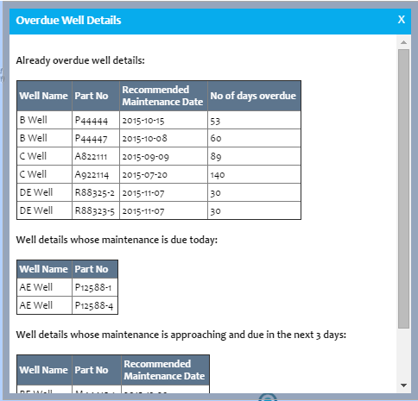

Clicking on the  and  buttons will close Overview Well Details page.

1. **Map View of Wells**

This page is used to show the regions of wells.

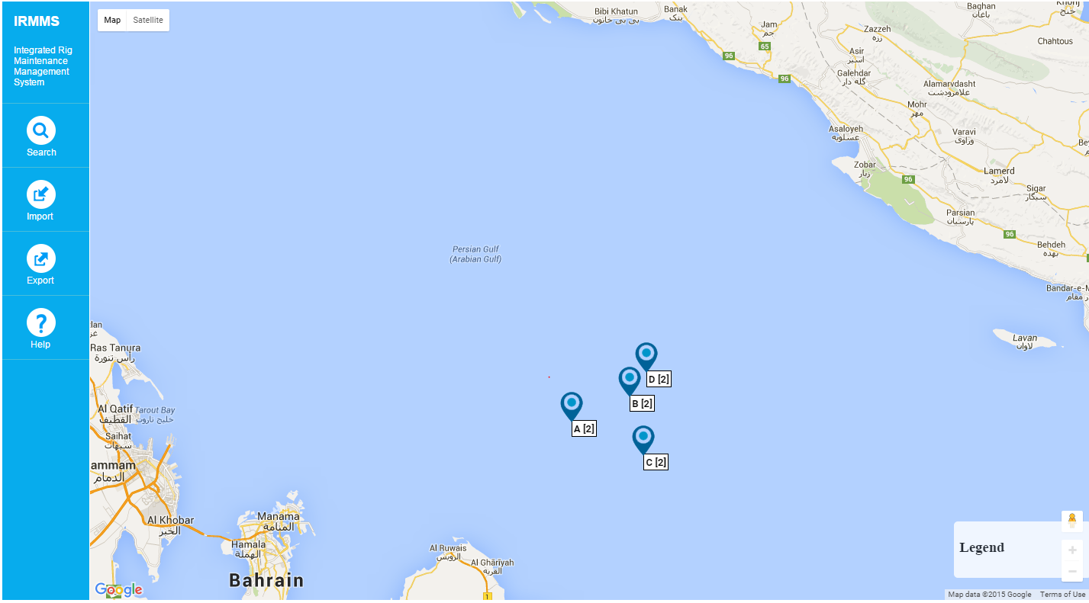

Clicking on the  particular region will display the wells under that region like below

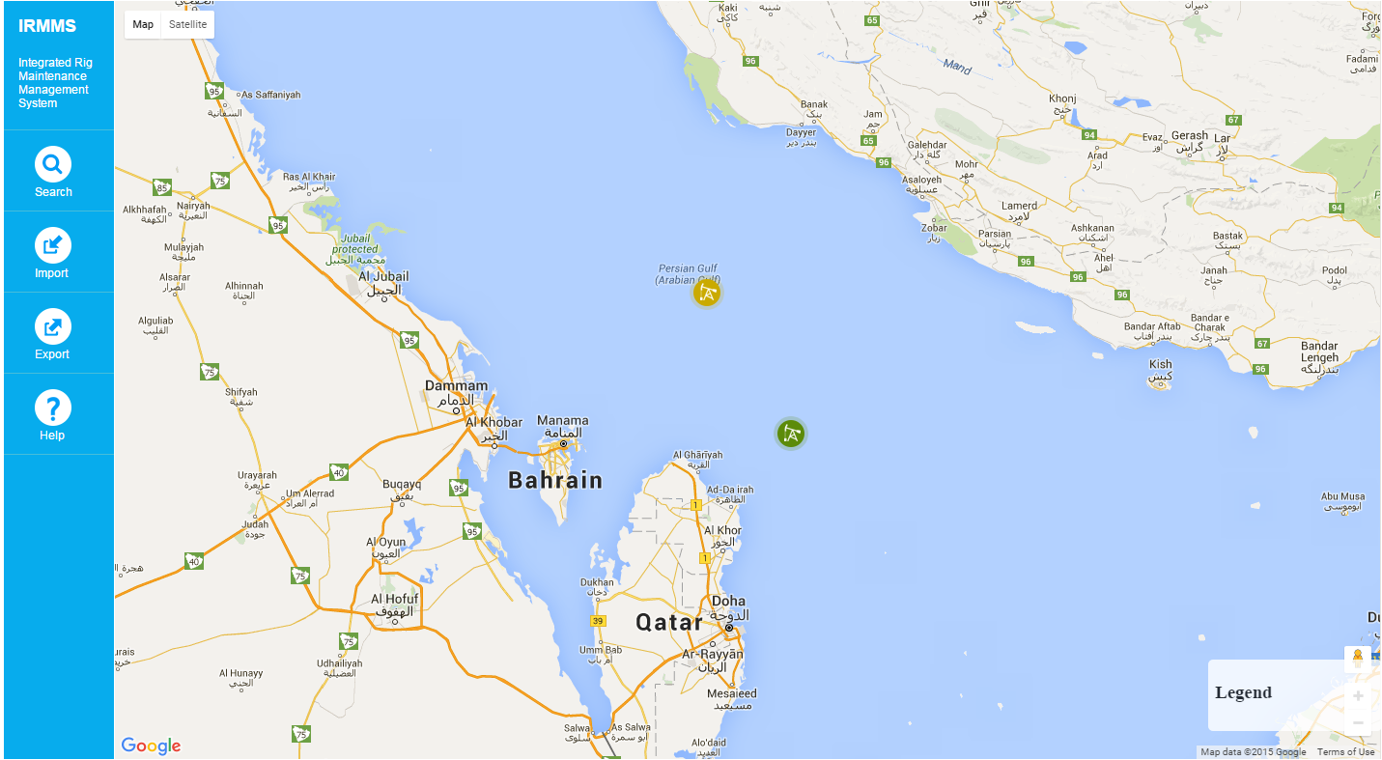

**Legend** - It is showing the explanation of color code for wells.

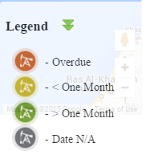

**Well image** - Clicking on the particular well will navigate to “Well Info” page.

1. **Well Info**

This page is used to show the selected well details.

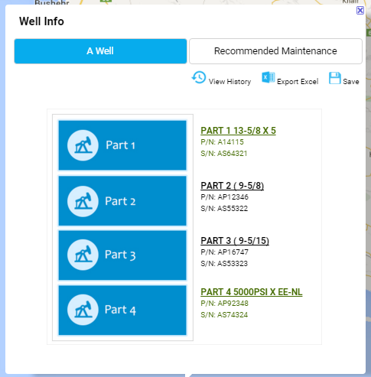

**View History **

Clicking on this button will display the history of the parts details.

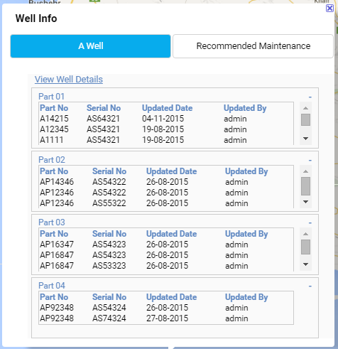

Clicking on the linkwill navigate to “Well Info” page.

**Export Excel** 

Clicking on this button will download the excel file with the particular well details.

**Save**  

In Well Info page, part number (P/N) and serial number (S/N) fields are editable.

Clicking on this save button can save the edited part number and serial number values in database.

**Recommended Maintenance Tab**

Clicking on this tab will navigate to “Recommended Maintenance” page. It is used to display the maintenance details of well parts.

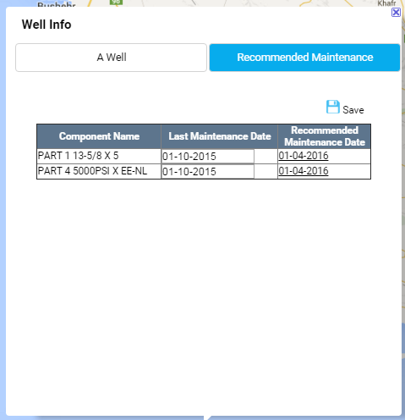

**Save**  

In Recommended Maintenance page, “Last Maintenance Date” field is editable.

Clicking on this field will show the calendar page like below.

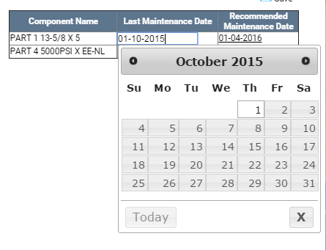

E.g.: we selects todays date in Last Maintenance Date, the Recommended Maintenance Date will change with 6 Month difference.

Clicking on this save button can save the changed values in database.

**Close** 

Clicking on this button will close Well Info page.

1. **Search** **icon** 

Clicking on search button in home page will open “Search Well” window likes below.

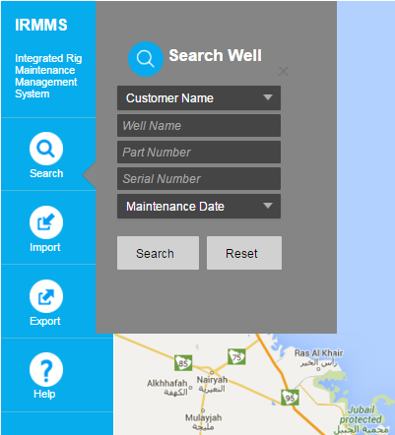

1. **Search Button**  

Clicking on this button will view the wells depends upon the selected criteria.

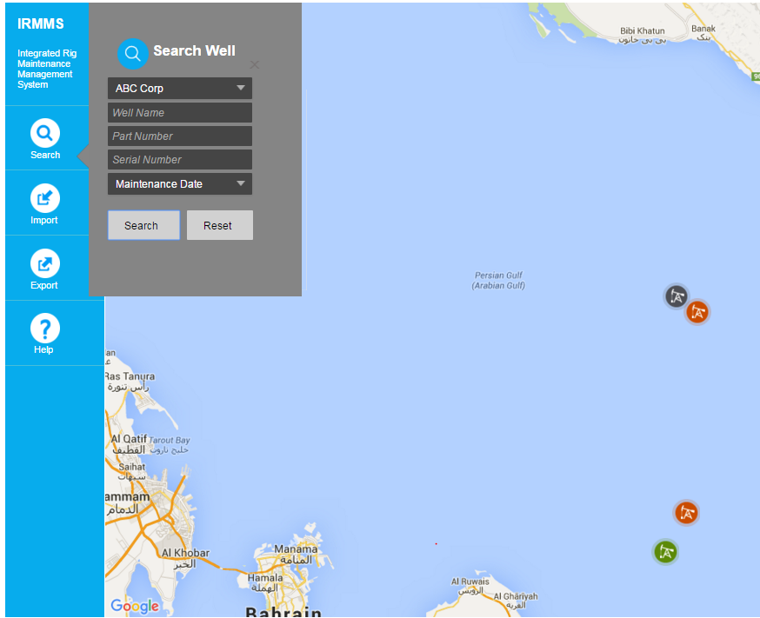

1. **Reset button** 

On clicking on this button will reset the search criteria fields.

1. **Import icon** 

Clicking on import button in home page will open “Import” window likes below.

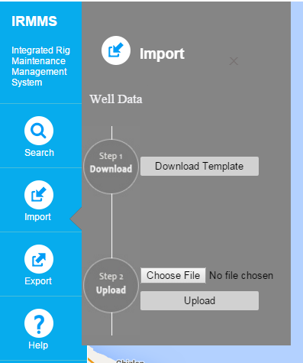

1. **Download Template** 

Clicking on this button will download the excel file which one have the required model template to upload the well details.

1. **Upload** 

First, clicking on the field “Choose File”  will open the new window for file (which one have the well details) chosen. This file should be in the format which one got downloaded by using “Download Template” button.

Then, Clicking on the upload button will upload the well details in database.

1. **Export icon** 

Clicking on this button will download the excel file which one have all well details under all the regions.

1. **Help icon** 

Clicking on this button will download the file which one is very useful to know about this application.